Shortest Job First (SJF) vs Priority Scheduling

1. Introduction
This project implements and compares two CPU scheduling algorithms. Shortest Job First (SJF) and Priority Scheduling. The goal is to analyze how each algorithm selects processes and to show the trade-off between efficiency and priority.

2. Algorithm Explanation

2.1 Shortest Job First (SJF)
Shortest Job First selects the process with the smallest burst time (execution time).
This algorithm aims to minimize the average waiting time of processes, making it efficient for system performance.

2.2 Priority Scheduling
Priority Scheduling selects the process with the highest priority.
Priority Rule Used in This Project:
1 = Highest priority
Larger numbers = Lower priority
This means a process with priority 1 will always be executed before a process with priority 2 or higher.

3. Test Scenarios
3.1 Test Case 1 (Normal Case)

Process | Burst Time | Priority
P1 | 5 | 2
P2 | 3 | 1
P3 | 8 | 3
SJF Execution Order:
P2 → P1 → P3
Priority Execution Order:
P2 → P1 → P3
In this case, both algorithms produce the same execution order because the shortest job also has the highest priority.
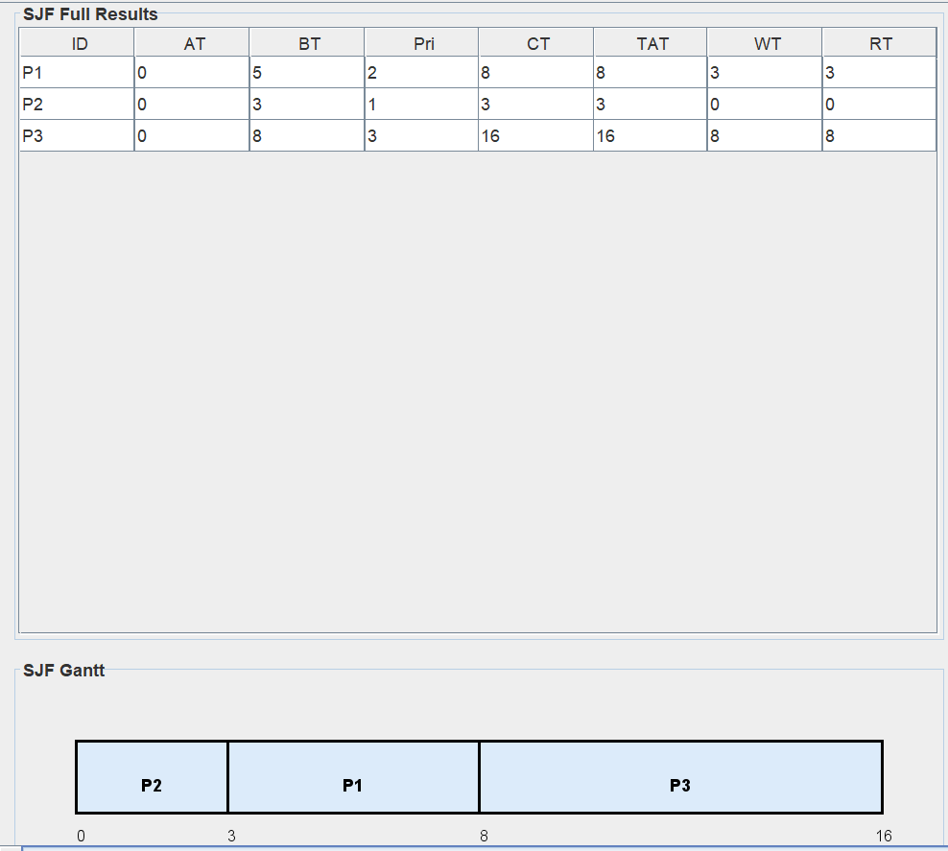
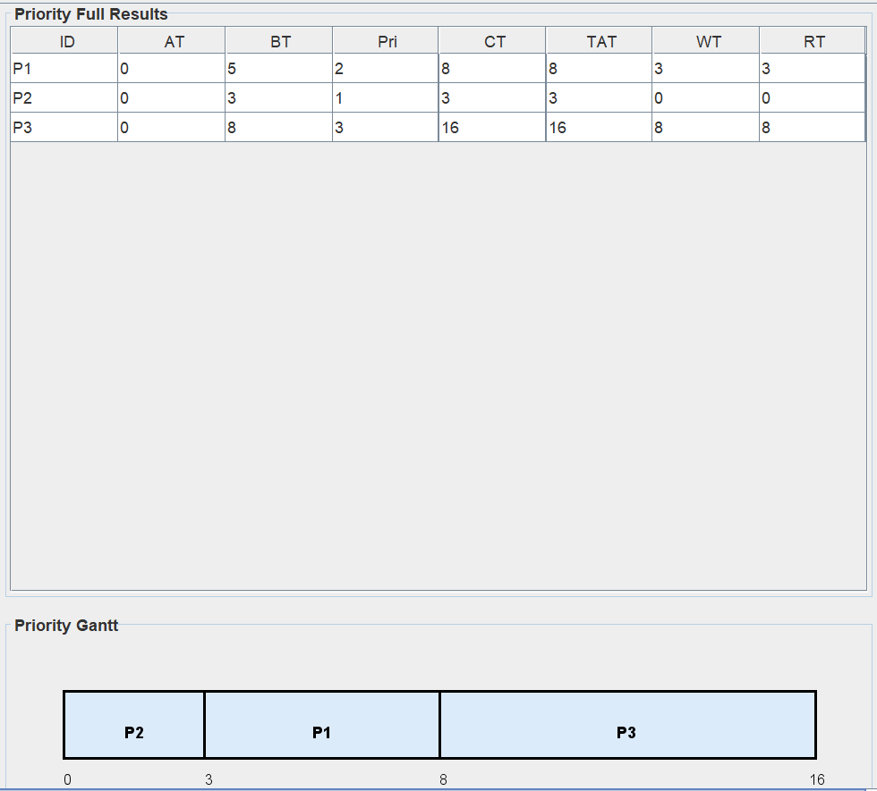

SJF Execution Priority execution

3.2 Test Case 2 (Behavior Revealing Case)
Process | Burst Time | Priority
P1 | 2 | 5
P2 | 10 | 1
P3 | 6 | 3
SJF Execution Order:
P1 → P3 → P2
Priority Execution Order:
P2 → P3 → P1
This case demonstrates a conflict between the two algorithms.
SJF selects the shortest job first (P1), while Priority Scheduling selects the most urgent job (P2).

SJF PRIORITY
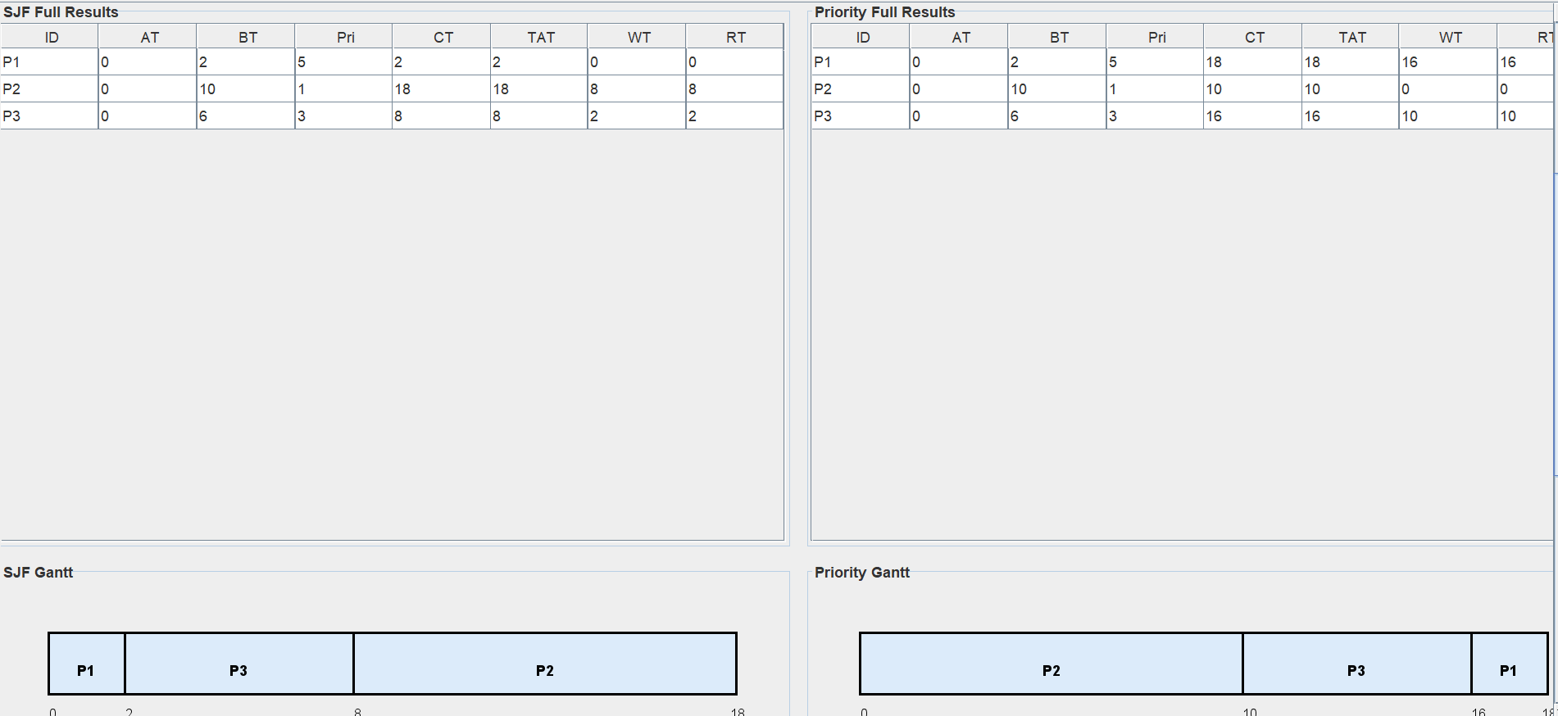

3.3 Test case 3 (Invalid Input Validation Case)

This test case ensures that the system properly handles incorrect or invalid inputs.
- Negative Burst Time
- Example: P1, Burst Time = -4
- Expected Behavior: Input rejected with error message.
2. Invalid Priority Values
- Example: Priority = 0 or non-numeric input
- Expected Behavior: System enforces valid priority range (e.g., 1 = highest)

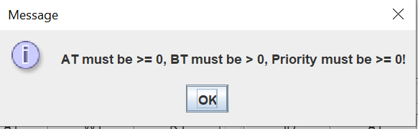

3. Missing Values
- Example: Process entered without burst time or priority
- Expected Behavior: Input is not accepted until all fields are filled.

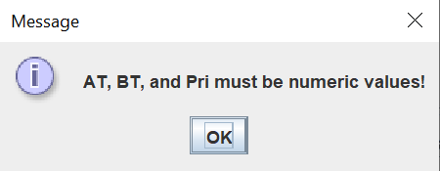

4. Duplicate Process ID
- Example: Two processes both labeled “P1”
- Expected Behavior: System prevents duplicate entries.
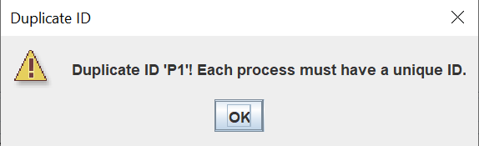

These validation checks ensure the robustness of the system by preventing incorrect data from affecting scheduling results. Proper input validation improves reliability and usability of the application.

4. Comparison
Algorithm | First Process Selected | Reason (As shown in Test case 2)
SJF | P1 | Shortest burst time
Priority | P2 | Highest priority
This comparison shows that SJF focuses on efficiency, while Priority Scheduling focuses on urgency.

5. Conclusion
Shortest Job First (SJF) improves system efficiency by minimizing waiting time.
Priority Scheduling ensures that critical or urgent processes are executed first.
However, there is a trade-off between efficiency and urgency:
- SJF may delay important tasks
- Priority Scheduling may increase waiting time for longer or lower-priority tasks
Choosing the appropriate algorithm depends on the system requirements and whether efficiency or priority is more important.

6. Notes
- Both algorithms were tested using the same datasets for fair comparison.
- The implementation was shown through the project GUI.

